** **

9B19m090

Smaart Home Furniture: ADDING VALUE BY ADDING SERVICES

[Vidya Suresh](https://iveypubs.my.salesforce.com/003A000001CqZLX) and M. Selvalakshmi wrote this case solely to provide material for class discussion. The authors do not intend to illustrate either effective or ineffective handling of a managerial situation. The authors may have disguised certain names and other identifying information to protect confidentiality.

This publication may not be transmitted, photocopied, digitized, or otherwise reproduced in any form or by any means without the permission of the copyright holder. Reproduction of this material is not covered under authorization by any reproduction rights organization. To order copies or request permission to reproduce materials, contact Ivey Publishing, Ivey Business School, Western University, London, Ontario, Canada, N6G 0N1; (t) 519.661.3208; (e) cases@ivey.ca; www.iveycases.com. Our goal is to publish materials of the highest quality; submit any errata to publishcases@ivey.ca. i1v2e5y5pubs

Copyright © 2019, Ivey Business School Foundation Version: 2019-09-06

We want to give value for money and keep innovating on our product line. We should be a multi-specialty furniture outlet with continuous innovation on quality and product line.

Chandran Periasamy, Managing Director, Smaart Home Furniture

At 7.45 p.m., on February 25, 2016, Chandran Periasamy, founder and managing director of Smaart Home Furniture; his staff; and the showroom manager in Madurai, India, were busy attending phone calls with enthusiasm and smiles. The calls seemed to be never-ending. It was an unexpected amazing response from Madurai and the surrounding area after Periasamy had arranged for an advertisement on sofa servicing (see Exhibit 1). Sofa servicing included repairs to the springs, foam, fibre, or covering to give the sofa new appearance and shape. The showroom manager, Rajesh Kumar, was overwhelmed by the response:

We got almost 270 calls so far in a single day, and my staff is still attending the calls. It’s 9.30 p.m. now. Of these, 120 calls were just enquiries and almost 70 to 80 calls were prospective customers who wanted us to take their sofa and get it done completely. Given our present set-up and facility, we can confidently take orders from 28–30 customers per day. Though we have full-fledged workshops, artists, and skilled carpenters, we are not prepared to commit more than 30 for a day. I want to do a good job, and this is our first venture into services.

Furniture manufacturing was Smaart Home Furniture’s core business, which generated an annual turnover of US$1.3 million.[1] In 2016, the company employed nearly 38 staff in its showrooms. The company’s workshops operated in five cities: Chennai, Coimbatore, Madurai, Tirupur, and Trissur.[2] The furniture market was highly competitive in Madurai and in other states in India. As of 2015, the Indian furniture market, which had an estimated worth of $17,922 million, had been predominantly driven by the unorganized market, which accounted for nearly 85 per cent of all sales. The Indian furniture industry had seen a steady 12 per cent annual growth in demand from 2009 to 2013 and averaged between 15 per cent and 17 per cent annual growth in demand since 2014. The key players in the organized sectors included Godrej Group (Godrej),[3] which had $80 million in sales in 2015 and Style Spa, which had $30 million in sales in 2015. Multinationals such as American Hardwood Export Council (AHEC) viewed the Indian market as lucrative for both export and investment. Peter King, AHEC’s vice-chairman, said:

We are coming to India for the first time with the intention of promoting hardwood exports. What we understand about India is that the growth here is explosive. We want to make use of the huge and growing construction industry here.[4]

In 2005, AHEC sold $100,000 worth of hardwood obtained from oak, walnut, and cherry trees to India. Although these woods were popular in the United States, AHEC exported the kiln and dried wood, which was more suitable for making furniture, staircases, flooring, and kitchen cabinets to India. These products were worth more than $2 billion, of which 12 per cent was exported to India, a percentage that was expected to increase in the coming years.[5]

Several branded showrooms in India provided tough competition for Smaart Home Furniture, including DAMRO,[6] Godrej Interio,[7] HomeTown,[8] Zuari,[9] and Usha Lexus.[10] Competition from online furniture shopping came mainly from the Swedish multinational company IKEA.[11] In Madurai, 20–25 local players sold all kinds of furnishings, including accessories. These local players were never inclined toward brand building and did not seem concerned about pursuing brand building in the near future. They continued to operate their businesses by relying on loyal customers and word-of-mouth marketing.

Online shopping had recently become a successful phenomenon in the Indian furniture industry. The leading online players in India included Pepperfry Furniture, FabFurnish, Urban Ladder, and Snapdeal. Both traditional and online retail stores shared two key characteristics: they both required a process for billing customers and they both had to maintain a relationship with suppliers. Periasamy provided a thorough and detailed explanation for being reluctant to embrace online retail:

We cannot market our services through online platform. I am very clear that we need to promote and sell our services the way we have been doing for our products. The reach of our services has to take a different mode compared to our product. If we choose to plunge into online shopping, we need to address a few bottlenecks:

Issues with the payment system: Though Prime Minister Narendra Modi’s financial inclusion and literacy program is getting implemented, people in India are still not used to the online shopping system and there is not much penetration of the credit card system in the middle and bottom of the pyramid. They also don’t want to use transaction facilities offered by the credit cards. There is not much confidence shown in usage of credit cards as well as online payment system.

Shipping: Customers using the online shopping should be assured that the products that they have ordered would reach them in due time. We have partnered with courier services. The customers need to be assured that the online retailers are available offline as well. This gives them the psychological comfort that these companies can be relied upon.

Products offered at discounted rates:The online retailers save on the cost of building and employee salaries. Some part of this benefit should also be enjoyed by the online customers by a reduction in the price of the product. The customers should be conveyed this message that they are getting the products at a discounted price.

Language problems:Most Internet retail shops use English as their mode of communication. English may not be compatible with the majority of the Indian population. To increase the customer base, content in the online retail shops should be provided in the local language.

Psychological issues: Another reason why the concept of online shopping has not gained prominence in India is that Indians prefer to touch the products physically before buying them. This facility is provided through the multi-brand outlets, not available online. Studies have revealed the preferences of the customers towards the traditional shopping methods. Hence, the retailer online should first make it a point to spot the potential customers and accordingly plan out the product. If the customers are more open to online shopping, then nothing can be more beneficial. They save the time and effort to visit department stores and shopping malls. Products can be delivered by a click of the mouse.

The furniture industry in India comprised three sub segments: home furniture (65 per cent), office furniture (20 per cent), and contracted furniture (15 per cent). However, the residential organized market was predicted to triple in size to $1.3 billion in the next five years, as a result of changing tastes, including Indian customers’ preference for a Western furniture style. According to a 2014 KPMG report, the Indian furniture market share by product was as follows: bedroom, 40 per cent; work station, 20 per cent; living room, 15 per cent; kitchen, 10 per cent; seating, 8 per cent; and storage, 7 per cent.[12]

Survival was not difficult for Periasamy’s business, but to grow he needed to create a path for growth. Periasamy’s company was the first one to venture into the servicing of sofas as an organized business.

By 10:35 p.m., after a busy day of taking service calls, on February 25, 2016, the Smaart Home Furniture employees had left for home. Kumar and Periasamy had never imagined they would receive such an overwhelming response from the public. Providing service seemed to be a lucrative opportunity. Periasamy was contemplating whether the servicing of sofas should become part of the company’s regular business, but knew that doing so would require an increase in investment to procure raw materials and to determine the necessary logistics. He also wondered whether it might be better to offer the servicing occasionally, but at regular intervals. If he decided to pursue sofa care more widely, should he offer the service using his existing business brand of “Smaart Home Furniture” or should he brand it separately? With all these thoughts running in his mind, he left for the day.

Periasamy’S BACKGROUND

Periasamy had started his life as a theatre assistant in a surgical clinic in late 1986. With no proper job description, he worked long hours in all departments of the theatre, which earned him ₹250 per month.[13] In 1990, he moved to a multi-specialty hospital,[14] where he operated a cafeteria for workers on a part-time basis, which paid well and provided entrepreneurial experience. Two years later, in the late 1990s, Periasamy opened a Chettinad hotel[15] in downtown Tamil Nadu, which he later regretted. He purchased the land, built the hotel, and employed around 35 people to run the business. However, the hotel’s location was problematic due to a nearby infestation of flies, mosquitoes, and other insects, which led to the business’s failure and the loss of approximately ₹250,000. Periasamy decided to explore other opportunities outside India:

I went to the Middle East and, due to visa issues, had to work at times as a cleaner in hotels. I had no proper shelter, identity, or passport even. One day, I was identified as a Hindu and was asked to leave. Except for [learning] Arabic, I have not gained much from the Middle East.

He returned to India within four months not knowing how to take his career forward. He resumed his work in the surgical clinic at the multi-specialty hospital, and was promoted to ward secretary. His job profile included educating patients on their ailments, facilitating finance arrangements for treatment, and explaining dietary plans. Thanks to his administrative capabilities, he was promoted to administrative secretary in 1996. His job and life both seemed promising for Periasamy. In 2002, he was again promoted, this time to front office manager, earning a reasonable salary. The owner of the hospital paid education expenses for Periasamy’s child and provided other benefits as well. In 2003, the hotel’s pharmacy was found to have mishandled medicines and funds. There was some mismatch in stock of medicine. Periasamy commented:

I was in administration and therefore was asked to see through the accounts of the pharmacy store. To my surprise, the accounts were not tallying. I had no choice than to bring it to the notice of the chairman. I was in charge of the pharmacy at that time. After toiling for almost a fortnight, the issue was sorted out. Seeing my commitment and hard work, I was promoted as a commander in the same hospital with added responsibility of pharmacy.

Everything was going well, and I never realized that something unethical was going on under the carpet and I was completely oblivious of it. This was in 2009. There was a mishandling of money again in the same pharmacy. The medicines returned by patients were not reported. This was not accidental; it happened frequently without my knowledge. I was frustrated and stressed out completely. I immediately took a decision of quitting the job to take a break.

Despite repeated requests by the hospital management for Periasamy to stay, he resigned from the job that day. He recalls, “A decision once taken can never be changed. However, I felt, I had lost my identity and that people were recognizing me only as an employee of this multi-specialty hospital. In 2011, in the month of June, I thought of opening a furniture retail business.”

New Business Venture

Periasamy decided to follow a completely different direction in his career from that point on. “I never wanted to do anything which in the remotest sense was related to the hospital,” said Periasamy firmly. He travelled to China, Malaysia, Dubai, Bangalore, and Chennai, and visited stores and vendors to source products for his retail outlet. He slowly started receiving orders and named his venture “Smaart Home Furniture” in November 2011. He financed the opening of the furniture manufacturing business with capital collected and accumulated through various sources, including his personal savings of ₹5 million and plus another ₹5 million loaned to him by relatives, who had borrowed that amount from banks with interest.

Kumar, the Smaart Home Furniture manager, described the company’s rise to success:

First and foremost, we decided not to have steel and plastic in our furniture collection. Today, we have five showrooms in total. We have invested around [$75,400] for promoting the showrooms [see Exhibit 3]. We have plans to open four more in other districts of Tamil Nadu in the forthcoming years. We studied our customers’ taste and preferences and were always prompt and sensitive in taking good care of their requirements. Furniture was procured from nations like China, Malaysia, Indonesia, and Sri Lanka. It was then brought to the workshop for polishing and later sent to showrooms. Meanwhile, we started manufacturing furniture, including sofa sets, to substitute for our imports. Imports of sofa sets were becoming expensive. We were not able to service them properly. We lacked the skill to handle servicing of imported goods. Gradually, we reduced our imports and relied on our home production. The market responded well. I can proudly say that we have become part of our Prime Minister’s “Make in India”[16] movement. Lack of services for imported sofas made us a manufacturer, from trader, over a period of time.

While his business was successful in terms of customer acquisition, Periasamy faced challenges in maintaining the accounts. It took quite some time for him to implement standard procedures for billing and accounting. To understand the accounting processes, he joined some professional organizations in town, which gave him insight into management and increased his business confidence. He proudly confirmed having learned what not to do.

Periasamy spoke in 2014 about the direction of his business:

We wanted to scale up our business and our furniture showrooms. It is a generic product and there are local players who are already doing well and also have loyal customers for their products. Our problem was how to understand our customers and their needs in a better way. Should we become technology experts in providing solutions for the sofa service? How do we identify ourselves in the market? Maybe we need to come out of Smaart Home Furniture and take up servicing as a separate entity.

Kumar explained why sofa servicing was pursued:

We wanted to add something to our existing manufacturing so that we can be heard and seen in the market. We had never planned to leverage on activity of servicing sofa. This idea was just to communicate loudly to people that we have a service support from all our home furniture showroom. The strategy was to understand the interest levels and market for a sofa servicing [see Exhibits 2 and 3].

Periasamy arranged for a survey of the people who had responded to the sofa service advertisements, with the support of research students from a local reputable management school. Periasamy wanted to understand the respondents’ market sentiments, lifestyles, usage patterns, tastes, and preferences. The respondents were found to be predominantly from the middle-class and upper-middle-class segments. Of these, 51 per cent had owned their sofa for more than four years and 36 per cent had bought their sofa less than three years earlier. Almost 80 per cent of respondents had a sofa set in the price range of $150–$500, and 90 per cent of the furniture had been purchased from local venders. Sofas in black and brown shades dominated in approximately 60 per cent of households, and 70 per cent of respondents had both a three-seater and a two-seater sofa. Almost 85 per cent of households had a sofa covered in either Rexine or fabric.

The key concern that respondents raised about their furniture was damage to the cushions and seats. Surprisingly, more than 90 per cent of the customers surveyed preferred to repair their sofa, rather than replace it completely. The respondents were willing to spend up to 10–20 per cent of the original price of the sofa set on repairs, and 94 per cent were willing to wait 10–15 days to have their sofa repaired. Almost 90 per cent of respondents preferred the servicing to be done at the store, rather than at their home. Approximately 83 per cent preferred to repair their sofa because of the cost advantages, while 13 per cent preferred to repair because they did not want to lose their favourite sofa.

CLOSING

During one of his visits to Mumbai, Periasamy learned about the availability of a specialist in sofa cleaning. This proposition attracted him. He had thoughts of venturing into not only servicing sofas and but also cleaning sofas. Many questions and ideas started floating in his mind and he kept pondering the appropriate location for the business, its expansion, the market size and potential, the future for sofa servicing, and his service concept to compete with horizontal service providers such as UrbanClap and Housejoy. He was conscious that both businesses would require different marketing approaches, even though both of the businesses centred on the same product. Periasamy needed to decide whether he could extend his existing manufacturing business to also provide sofa services. He said with all confidence:

I am prepared to do free servicing of sofa with free logistics, maybe on trial runs. I have workshops and skilled people ready for that. I need to explore this market space. But I am contemplating whether to enter into servicing and if yes, how.

Exhibit 1: smaart home furniture’s Sofa servicing advertisement

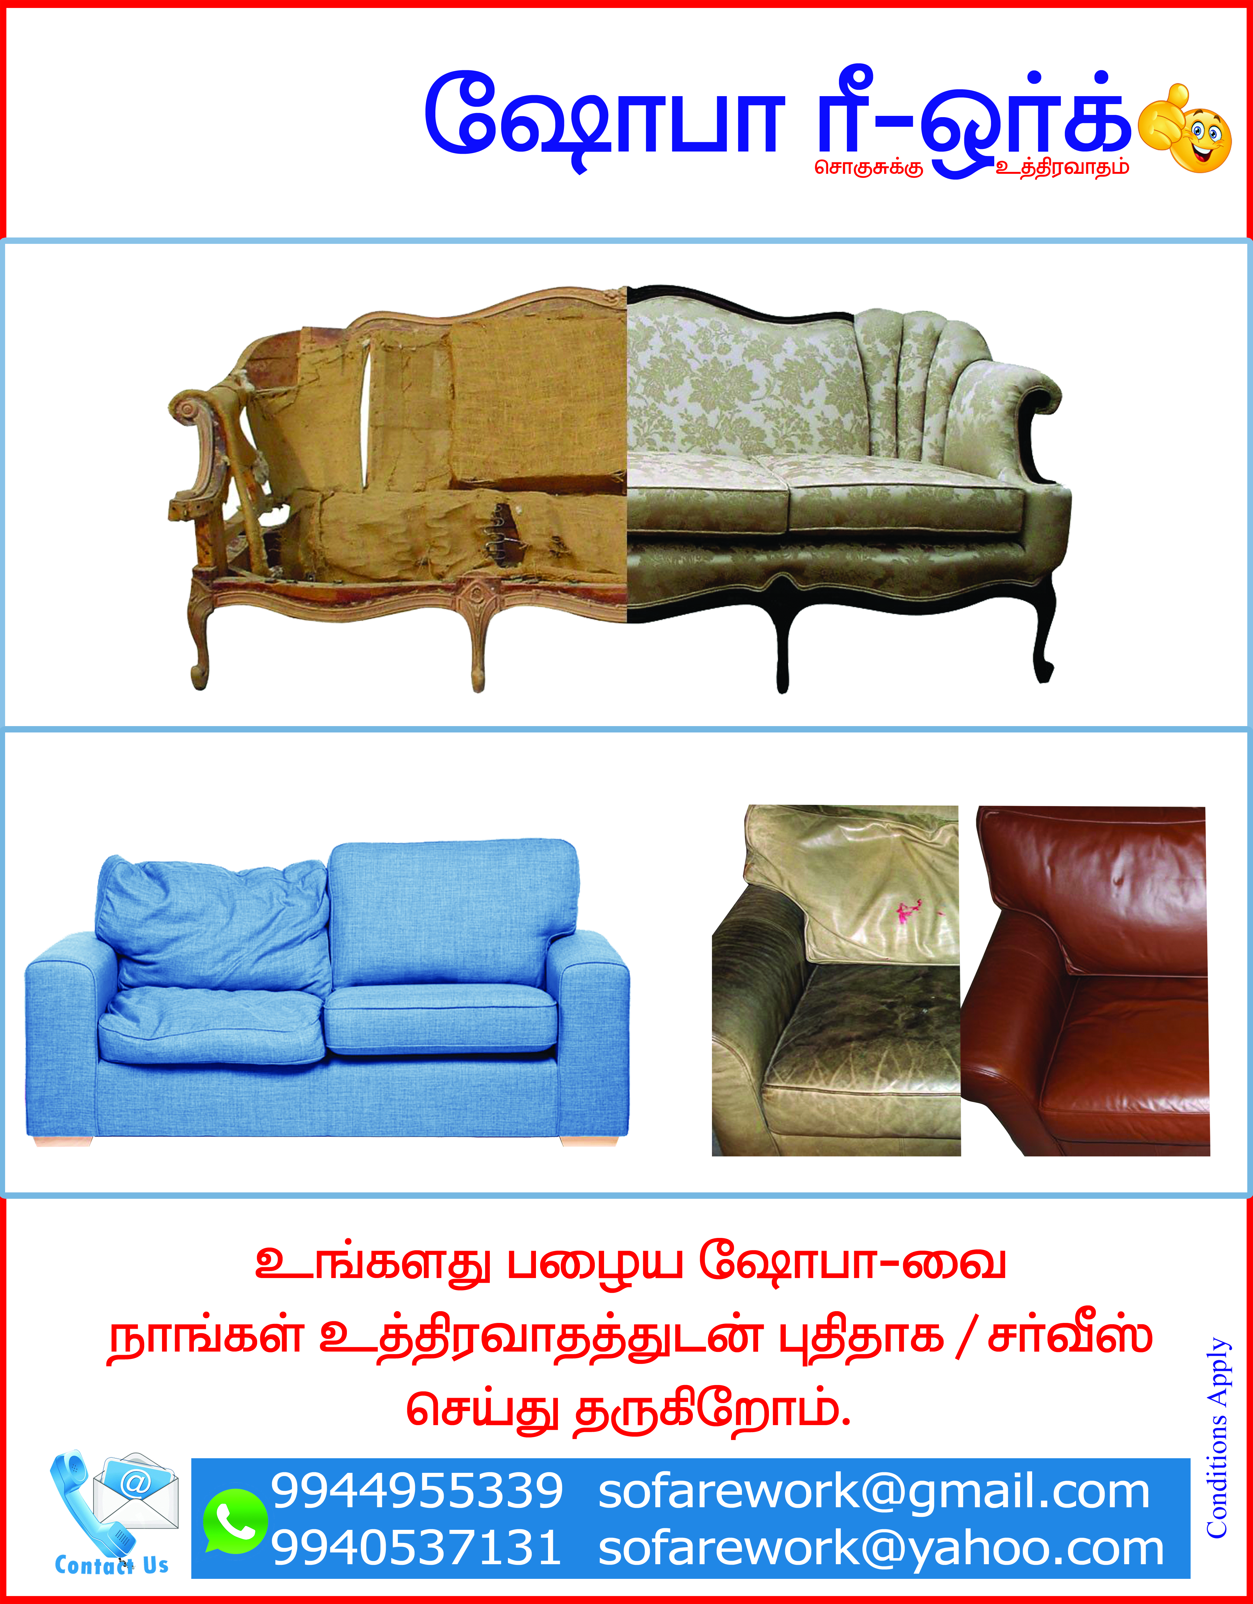

Note: The text in the advertisement reads: “Sofa Rework: We will do repair services for your old sofa with guarantee.”

Source: Company files.

Exhibit 2: smaart home furniture’s manufacturing process

Sofa production actually starts in the development department, where our most creative employees work to shape our upholstered furniture—and the styling trends of tomorrow. Actual manufacturing begins in the receiving department. This is where delivered goods such as wood, cover materials, and so on are minutely checked for quality, before being sent to the manufacturing department. All materials, including moulded foam components, small parts, and hardware are meticulously quality-checked, prior to being passed on to production.

In-house-produced plastic components are formed in our advanced frame assembly department using deep-drawing machines, and then finish-processed using band saws and table routers. Upholstery fabrics, non-woven fabrics, and canvas are sent via the fabric warehouse to the cutting department. Leather is cut in a department of specialist craftsmen with the same extreme care, using templates. Meanwhile, wadding is supplied to the cutting department on a “just-in-time” basis, to be prepared together with the fabric covers in the sewing department.

Wooden components and the finished foam mouldings are first sent to the frame and parts warehouse. These semi-finished parts will be assembled later in the frame assembly department, using sturdy screws, fittings, and other hardware. The visible wooden components are then given the required colour or finish in the paint or staining workshop.

Then it’s on to the final production department, where the prepared components arrive at production lines using automatic transport systems. They are assembled by teams of four. The finished upholstered furniture now reaches its most critical stage; it is subjected to the intense scrutiny of our quality control inspectors. Once it has been pronounced perfect, the SMAART HOME quality label is attached and the finished product goes to furniture stores.

Source: From an interview with Chandran Periasamy, October 10, 2018.

Exhibit 3: Smaart Home FURNITURE’S PROMOTION budget for the   
launch of a new showroom

|  |  |  |
| --- | --- | --- |
|  | **Description** | **Amount (in** ₹**)** |
|  | Invitations | 30,000 |
|  | Advertising in Hindu newspapers | 100,000 |
|  | Advertising in local newspapers | 300,000 |
|  | Celebrity expenses | 150,000 |
|  | Radio advertising | 200,000 |
|  | Wall posters | 25,000 |
|  | Gifts | 25,000 |
|  | Food and beverages | 150,000 |
|  | Miscellaneous expenses | 15,000 |
| **Total expenses** | | 995,000 |

Note: ₹ = INR = Indian rupee; US$1 = ₹66 in 2015–16, on average; 1,500 invitations were sent at a cost of approximately ₹20 each (1,500 × ₹20 = ₹30,000).

Source: Company files.

1. All currency amounts are in US$ unless otherwise specified.
2. Chennai, Coimbatore, Madurai, and Tirupur were located in the south-eastern state of Tamil Nadu, India; Trissur was located in the south-western state of Kerala, India.
3. The Godrej Group was owned by the Godrej family, an Indian conglomerate headquartered in Mumbai. It was founded by Ardeshir Godrej and Pirojsha Burjorji Godrej in 1897 and operated in various sectors, including real estate, consumer products, industrial engineering, appliances, furniture, security, and agricultural products. Godrej was also known for its philanthropic contributions that included schools, dispensaries, and a residential complex for its employees. Trusts established by Godrej continued to invest in education, health care, and the upliftment of the underprivileged. It was also a supporter of the World Wildlife Fund in India.
4. Mahesh Kulkarni, “US Body Targets $20 Million of Hardwood Exports to India,” *Business Standard*, February 25, 2013, accessed February 7, 2018, www.business-standard.com/article/economy-policy/us-body-targets-20-million-of-hardwood-exports-to-india-106021601090_1.html.
5. Ibid.
6. “About Us,” Damro, accessed November 15, 2018, www.damroindia.com/karnataka/about-us.
7. “About Us,” Godrej Interio, accessed November 15, 2018, www.godrejinterio.com/GodrejInterio/about-us.aspx?id=29&menuid=62.
8. “Who We Are,” HomeTown, accessed November 15, 2018, www.hometown.in/who-we-are.
9. “Who We Are,” Zuari Furniture, accessed November 15, 2018, www.zuari-furniture.com/about-us/.
10. “About Us,” Usha Shriram, accessed November 15, 2018, https://ushafurniture.com/about_us.php.
11. “This Is IKEA,” IKEA, accessed June 18, 2019, www.ikea.com/in/en/this-is-ikea/.
12. KPMG India Analysis, *Human Resource and Skill Requirements in the Furniture and Furnishing Sector 2013–17, 2017–22*, April 13, 2014, accessed November 15, 2018, https://nsdcindia.org/sites/default/files/Furniture-Furnishing.pdf.
13. ₹ = INR = Indian rupee; US$1 = ₹68.86 on February 25, 2016.
14. In India, a multi-speciality hospital referred to a hospital that provided several different medical specialist areas under one roof.
15. A Chettinad hotel featured Chettinad cuisine, which was from the Chettinad region of Tamil Nadu state in southern India. Chettinad cuisine was an aromatic cuisine known for its use of specific spices to prepare mainly non-vegetarian food.
16. Prime Minister Narendra Modi launched the Make in India initiative in September 2014, as part of his nation-building initiatives intended to transform India into a global design and manufacturing hub. “About Us,” Make in India, accessed April 2, 2017, www.makeinindia.com/about.